Student Performance Prediction System

Project Id: 04

Name : VANSHIKA PRAJAPATI
Class Roll Number: 22
University Roll Number : 2028513
Section and Group: G(G1)

Name : ISHANAYA AGARWAL
Class Roll Number:08
University Roll Number : 2028433
Section and Group: G(G1)

Name : SHAGUN
Class Roll Number:18
University Roll Number : 2028489
Section and Group: G(G1)

TABLE OF CONTENTS
- Problem Description 3
  - Dataset Description 3
  - Flow diagram 4
- Modules for Project Implementation…………………..…………………………6
  - Modules Used 6-7
  - Platform Used 8
- Machine Learning model/ Searching Technique used 9
- Evaluation metrics used 10
- Results and Visualizations 11-12
- Conclusion and Future Scope 13
- References 14

- Problem Description
The Agricultural Region Clustering System is a Machine Learning-based analytical project designed to group agricultural regions based on environmental conditions and crop yield characteristics.
Agriculture depends on multiple factors such as rainfall, temperature, soil nutrients, irrigation, and farming practices. Analyzing these factors individually is difficult and time-consuming. This project solves that problem by using K-Means Clustering, an unsupervised machine learning algorithm, to automatically group regions with similar characteristics.

The main objective is to:
- Identify similar agricultural zones
- Help in better decision-making for farming strategies
- Improve crop productivity
- To analyze agricultural data using Exploratory Data Analysis (EDA)
- To preprocess and normalize multi-dimensional data
- To identify important features using feature selection
- To group regions using K-Means clustering
- To evaluate clustering performance using Silhouette Score
- To predict clusters for new agricultural data

1.1 Dataset Description
The dataset consists of 20 features, including:
- Rainfall (mm)
- Temperature (°C)
- Soil moisture (%)
- Soil pH
- Nitrogen, Phosphorus, Potassium
- Irrigation coverage (%)
- Crop area
- Fertilizer & pesticide usage
- Sunlight hours
- Humidity (%)
- Altitude, wind speed
- Groundwater level
- Crop diversity index
- Mechanization score
- Yield variance
- Average crop yield

  - Flow Diagram

Exploratory Data Analysis (EDA)
- Displayed dataset structure using head(), info()
- Checked shape and size of dataset
- Identified missing values
- Used heatmap to analyze correlations

Data Preprocessing
- Missing values replaced using mean imputation
- Data normalized using StandardScaler
- Boxplots used to detect outliers

Feature Selection
- Applied Backward Feature Elimination
- Selected most relevant features for clustering
- Reduced dimensionality and improved efficiency

K-Means Clustering
- Applied K-Means algorithm to grouped data
- Data points assigned to nearest cluster centroid

Optimal Cluster Selection
- Used Elbow Method
- Plotted WCSS vs number of clusters
- Selected optimal K (example: K = 3)

Evaluation
- Used Silhouette Score
- Evaluates how well clusters are separated
- Higher score indicates better clustering

Visualization
- Used PCA (Principal Component Analysis)
- Converted high-dimensional data into 2D
- Visualized clusters clearly

Prediction
- Model predicts cluster for new input data
- Demonstrates real-world applicability

2. Modules for Project Implementation

2.1 Modules Used(mention all the inbuilt/ custom modules used and the purpose)

1. Pandas
Pandas module has been used for data manipulation and analysis.
- pd.read_csv() – to read dataset from CSV file
- df.head() – to display first few rows
- df.tail() – to display last few rows
- df.info() – to get dataset information
- df.shape – to get number of rows and columns
- df.isna() – to check missing values
- df.fillna() – to fill missing values with mean
- df.corr() – to calculate correlation between features

2. NumPy
NumPy module has been used for numerical computations.
- np.array() – to create arrays
- Mathematical operations on arrays for calculations

3. Matplotlib
Matplotlib module has been used for basic data visualization.
- plt.plot() – to plot Elbow graph
- plt.scatter() – to plot data points
- plt.xlabel() – to label x-axis
- plt.ylabel() – to label y-axis
- plt.title() – to give title to graph
- plt.show() – to display plots

4. Seaborn
Seaborn module has been used for advanced visualization.
- sns.heatmap() – to display correlation heatmap
- sns.boxplot() – to visualize data distribution
- sns.scatterplot() – for PCA cluster visualization

5. Scikit-learn (sklearn)

a) StandardScaler
Used for data normalization.
- fit_transform() – to scale data into standard format

b) KMeans
Used for clustering data into K groups.
- KMeans() – to initialize model
- fit() – to train clustering model
- predict() – to assign cluster labels
- inertia_ – to get WCSS value

c) PCA (Principal Component Analysis)
Used for dimensionality reduction and visualization.
- PCA(n_components=2) – to reduce data to 2 dimensions
- fit_transform() – to transform data

d) silhouette_score
Used to evaluate clustering performance.
- silhouette_score() – to calculate clustering quality

e) SequentialFeatureSelector
Used for feature selection (backward elimination).
- fit() – to select important features

2.2 Platform Used: (mention all the platforms with the reason of using it)

1. Python
- Used for implementing machine learning algorithms
- Easy to use with strong libraries for data analysis

2. Google Colab
- Used for writing and executing code
- Provides interactive environment for data analysis and visualization

3. Pandas
- Used for data manipulation and preprocessing
- Helps in handling datasets easily

4. NumPy
- Used for numerical computations
- Supports fast mathematical operations

5. Matplotlib & Seaborn
- Used for data visualization
- Helps in plotting graphs like heatmaps, scatter plots

6. Scikit-learn
- Used for implementing ML models
- Provides K-Means, StandardScaler, PCA, and evaluation metrics

- Machine Learning Model/ Searching Technique Used(Describe each ML model/ searching technique used)

1. K-Means Clustering (Machine Learning Model)
K-Means is an unsupervised learning algorithm used to group data into K clusters based on similarity.
- Each cluster has a centroid (center point)
- Data points are assigned to the nearest centroid
- The algorithm updates centroids iteratively until convergence
Purpose in project:
To group agricultural regions with similar environmental and crop characteristics.

2. Elbow Method (Searching Technique)
The Elbow Method is used to find the optimal number of clusters (K).
- Runs K-Means for different values of K
- Calculates WCSS for each K
- The “elbow point” indicates the best K
Purpose in project:
To select the most suitable number of clusters for accurate grouping.

3. Sequential Feature Selection (Backward Elimination)
A technique used to select the most important features.
- Starts with all features
- Removes least important ones step by step
Purpose in project:
To improve clustering performance and reduce complexity.

4. PCA (Principal Component Analysis)
A dimensionality reduction technique.
- Converts high-dimensional data into 2D
- Helps in visualization of clusters
Purpose in project:
To clearly visualize clustered agricultural regions.
4. Evaluation metrics used (Describe each evaluation metric used along with formulae)

1. Elbow Method (WCSS)
Used to find the optimal number of clusters (K).
WCSS=∑i=1k∑x∈Ci∣∣x−μi∣∣2WCSS = \sum_{i=1}^{k} \sum_{x \in C_i} ||x - \mu_i||^2WCSS=∑i=1k​∑x∈Ci​​∣∣x−μi​∣∣2
- Lower WCSS = better clustering
- Elbow point gives optimal K

2. Silhouette Score
Measures how well data points are clustered.
s=b−amax⁡(a,b)s = \frac{b - a}{\max(a, b)}s=max(a,b)b−a​
- Range: -1 to 1
- Higher value = better clusters

5. Results and Visualizations
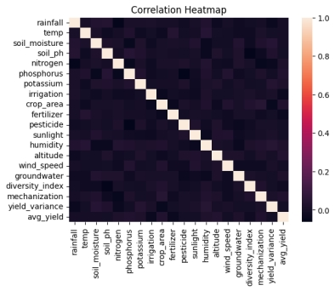

FIG1. Correlation HeatMap

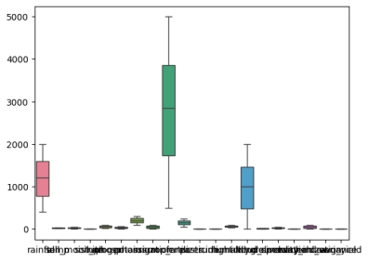

FIG2. Boxplot for Outliers
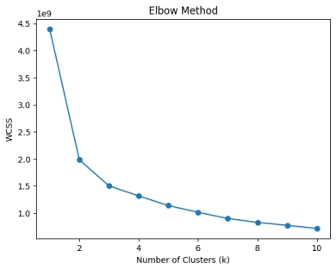

FIG3. Elbow method
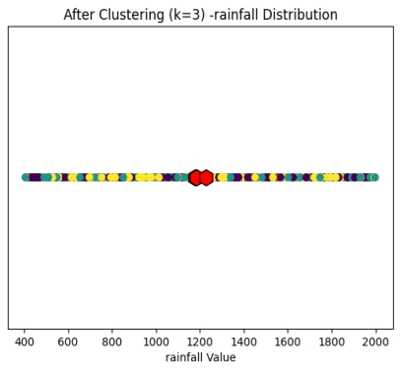

FIG4. After clustering (k=3)

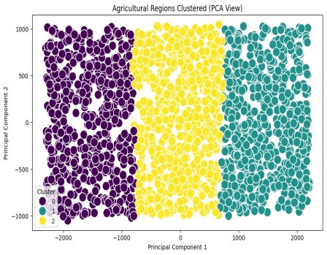

FIG5. PCA for Visualization

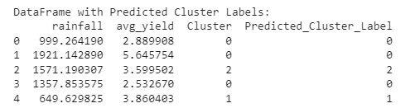

FIG6. Predicted Cluster

6. Conclusion and Future Scope:
The Agricultural Region Clustering System using K-Means successfully demonstrates how machine learning can be applied to analyze complex agricultural data. By considering multiple environmental and crop-related factors such as rainfall, soil nutrients, temperature, and yield, the system effectively groups regions with similar characteristics.
The use of Exploratory Data Analysis (EDA) helped in understanding data patterns, while preprocessing techniques like normalization ensured fair comparison between features. Feature selection improved model efficiency by focusing only on the most relevant variables.
The Elbow Method was used to determine the optimal number of clusters, and K-Means clustering successfully categorized regions into meaningful groups. The Silhouette Score validated the quality of clustering, and PCA visualization made cluster interpretation easier.
Overall, the system provides valuable insights that can assist in better agricultural planning, resource allocation, and decision-making.

Future Scope
The project can be further enhanced in several ways:
- Advanced Algorithms:
Implement more robust clustering techniques such as DBSCAN or Hierarchical Clustering for better accuracy.
- Real-Time Data Integration:
Incorporate real-time data from weather APIs, sensors, and satellite imagery for dynamic analysis.
- Web-Based Dashboard:
Develop an interactive dashboard for farmers and policymakers to visualize clusters and insights easily.
- Geographical Mapping:
Integrate GIS-based visualization to display clusters on actual maps.
- Predictive Analytics:
Combine clustering with predictive models to forecast crop yield and risks.
- Scalability:
Extend the system to handle large-scale national or global agricultural datasets.
- AI-Based Recommendations:
Provide suggestions for crop selection, irrigation, and fertilizer usage based on cluster analysis.

7. References:
Books:
- Let Us Python – Yashavant Kanetkar

Online Resources:
  - GeeksforGeeks – https://www.geeksforgeeks.org/
  - TutorialsPoint – https://www.tutorialspoint.com/cprogramming/index.htm
  - Stack Overflow – https://stackoverflow.com

